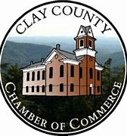 **Corporate Sponsors**

**2025 PUNKIN CHUNKIN SPONSOR LIST**

Harrah’s Cherokee Valley River Casino & Hotel

Big Bear Veterinary Clinic

Blue Ridge Mountain EMC

**Festival Sponsors**

Budweiser of Silva

Chatuge Family Practice

Freedom Boat Club

First Citizens Bank

Men On The Move

Miller Well Drilling

Moore Insurance

Mountain Sunrise Realty

**Diamond Sponsors**

Clay County Government

David Rogers construction

Eagle Fork Vineyards

Erlanger Western Carolina Hospital

George’s Paint & Hardware

Ingles Markets, Inc.

Jason’s Professional Painting

Kinetic Windstream

Ledford & Parker, Inc.

Sonja Silvers Realty Group

State Farm – Steven Aft

WJUL Lake 97.7 / WJRB Newstalk 95.1

WKRK Radio